1. ID 65 and 66 are from the same publication. Meng can’t find the soil C data from the PDF.

***[Response from Blanca]*** *Same as above, you need to make sure this guy did not have 2 papers in the same year. It is frequent to have more than one from the same region. The C pool seems sufficiently different to think that the papers are not the same. Please search for a second paper online. Or review the paper to make sure it doesn’t describe 2 different sites..*

Meng found the right PDF for this publication: “65-Markewich 1998 (Mississippi Basin Carbon Project Process Studies)”

The paper does not report carbon density directly. We calculated carbon density from Fig. 10 and 11 for site SB1a and SB1c, which reported percent organic carbon and bulk density. To calculate carbon density, their data were entered into a spreadsheet, then processed with SAS code to calculate carbon density. The calculation steps were as follows:

a. Convert soil carbon concentration (SoilCC) to carbon density.

SC=SoilCC*BD/100, where

SC=Soil carbon density in units of grams carbon per cubic centimeter (g/cm3)

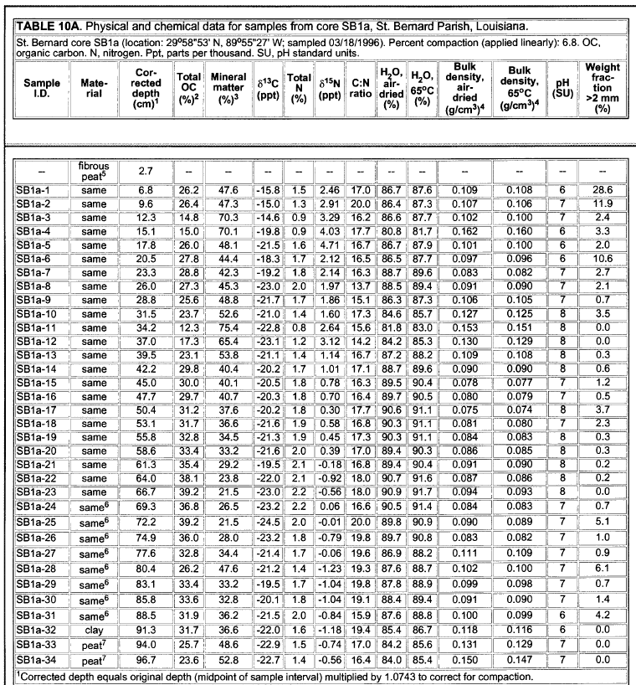

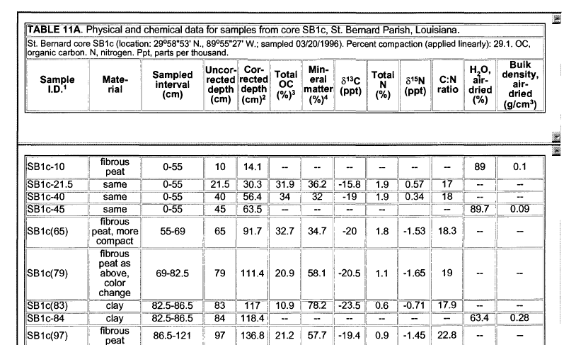

Soil C rate data was from Table 13.

